Administration Guide

U N I K R E W S O L U T I O N S

Contents

Users 3

Forgotten Password 9

Password Policy 12

Groups 16

Fields 23

Entities 31

Product 36

Records 39

# Users

Maker

1. Click on ‘users’ under the ‘identity’ tab.

2. Click on ‘new user’ to create a new user.

3. Fill all the required fields, then select groups under ‘authorized groups’ from a drop down menu.

**Note**: With authorized groups you can assign different rights to a user which can include modules, tabs, etc.

4. Once you have filled all the fields, click on ‘submit & stay’ to save and stay on the page, or click on ‘submit’ to submit and leave the page.

5. Your newly created user will now show under the ‘pending’ tab.

6. If you want to make any changes to the user, you can click on ‘edit’ to do so. You can also duplicate the user by clicking on ‘clone item’ or delete it by clicking on ‘delete item’.

7. After you are done with making all changes, select the user by ticking the check box then click on the ‘maker checker action’ button.

8. Leave comments then click on ‘send for approval’.

Checker

1. From the checker account, click on the ‘identity’ tab then on ‘Users’.

2. Then click on ‘pending’. Here you will see the users that require approval including the one that was just created.

3. Select a user by ticking the check box, then click on the ‘maker checker action’ button.

4. Leave a comment, then click on ‘approve’ to approve the user. You can also click on ‘reject’ to reject the user or click on ‘send for review’ to send it to a third person for further reviewal.

5. After the approval, the newly created user will now show as approved under the ‘approved’ tab. An email will also be sent to the email address of the new user entered during the user creation process.

6. Click on the email to activate the new user account.

7. Then click on the link to activate the account.

8. The user will be prompted to create a new password to activate the account. Enter the password then click on submit.

## Forgotten Password

1. In case of a forgotten password, click on the ‘forgot password’ button on the login page.

2. Then email will be sent to your registered email address, click on that email.

3. Click the link in the email.

4. Enter a new password then click on submit.

5. You will then receive a notification saying that your password has been changed successfully.

# Password Policy

Maker

1. Go the ‘records’ tab.

1. Select ‘Password Policy’ from the dropdown menu.

1. Click on ‘edit’ to edit the existing password policy.

1. You can edit the fields such as ‘allowed invalid attempts’, ‘min & max lengths of the password’, ‘inactivity timeout’ etc. to your liking.

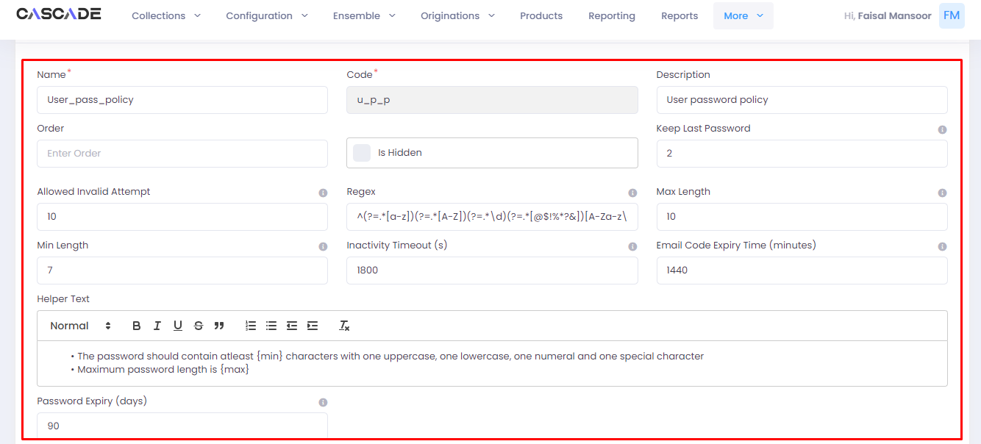

1. Click on ‘submit’ to save the changes.

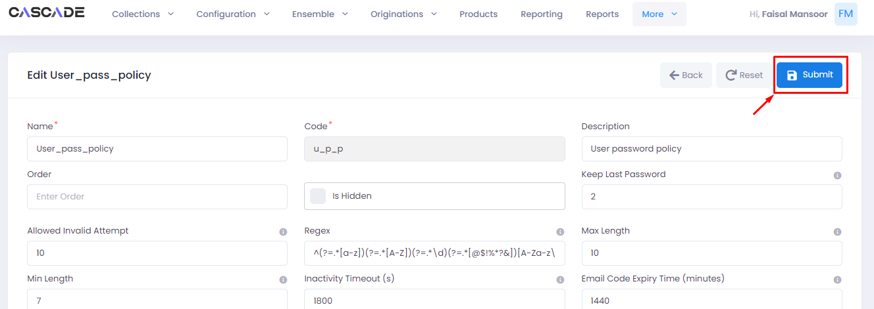

1. Under the ‘pending’ tab, select the record you edit by ticking the checkbox.

1. Then click on the ‘maker checker’ button.

1. Leave comments then click on ‘send for approval’ button.

Checker

1. From the checker account, click on the ‘records’ tab.

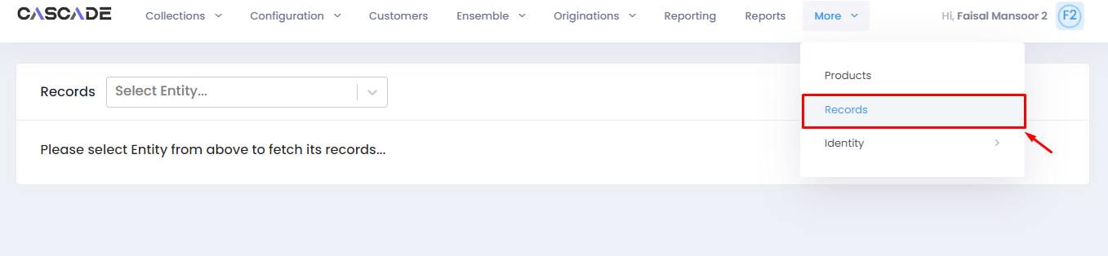

2. Select ‘password policy’ from the dropdown menu.

3. Then click on ‘pending’. Here you will see the items that require approval including the password policy that was edited.

4. Select the record by ticking the checkbox.

5. Click on the ‘maker checker’ button.

6. Leave comments, then click on ‘approve’.

# Groups

Maker

1. Click on the ‘groups’ tab.

2. Click on ‘new group’ to create a new group.

4. Fill all the required fields, then click on the ‘add modules’ (1) button to select modules from a drop down menu. 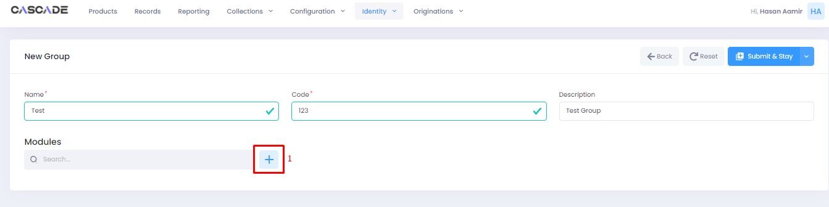

5. After you select a module, you will further be able to select the rights to assign relevant to the selected module.

6. After you have selected a module, you can add more modules by following the same procedure. Once done, click on ‘submit & stay’ to save and stay on the page, or click on ‘submit’ to submit and leave the page.

7. Your newly created group will now show under the ‘pending’ tab.

8. If you want to make any changes to the group, you can click on ‘edit’ to do so. You can also duplicate the group by clicking on ‘clone item’ or delete it by clicking on ‘delete item’.

9. After you are done with making all changes, select the group by ticking the check box then click on the ‘maker checker action’ button.

10. Leave comments then click on ‘send for approval’.

Checker

1. From the checker account, click on the ‘Groups’ tab.

2. Then click on ‘pending’. Here you will see the groups that require approval including the one that was just created.

3. Select a group by ticking the check box, then click on the ‘maker checker action’ button.

4. Leave a comment, then click on ‘approve’ to approve the group. You can also click on ‘reject’ to reject the group or click on ‘send for review’ to send it to a third person for further reviewal.

5. The newly created group will now show as approved under the ‘approved’ tab.

# Fields

Maker

1. Click on the ‘fields’ tab.

2. Here you will see all the approved fields.

3. Click on ‘new field’ to create a new field.

4. Fill all the required fields.

5. ‘Data type’ will allow you to choose the type of field to create.

**For example, ‘select’ will create a field with a drop down menu. ‘String’ will create a field with an empty text box.**

6. ‘Master data type’ will allow you to select the options shown under the drop down menu if you choose ‘select’ as the data type.

7. ‘Tags’ will allow you set certain parameters for the field that you are creating.

8. These are some of the checkboxes that you can tick to change the nature of the field.

‘Mandatory’ makes the field mandatory to fill. ‘Readonly’ makes the field read-only. ‘Hidden’ keeps the field present but hidden.

9. Once completed, click on ‘submit & stay’ to submit and stay on the page, or click on ‘submit’ to submit and leave the page.

10. New field will now appear under the ‘pending’ tab.

11. Select the new field by ticking the check box then click on the ‘maker checker action’ button to send it for approval.

12. Leave comments then click on ‘send for approval’ button.

**Note**: The newly created field will now require approval from a checker.

Checker

1. Go to the ‘fields’ tab from the checker account.

2. Then click on the ‘pending’ tab where you will see all the pending entries. Select the one that requires approval by ticking the check box, then click on the ‘maker checker action’ button.

3. Leave comments then click on ‘approve’ to approve.

4. The newly created field will now show as approved. You can also edit, clone, or delete it.

# Entities

Maker

1. Click on the ‘entities’ tab.

2. Click on ‘new entity’ to create a new entity.

3. Fill all the required fields.

4. You can also choose ‘fields’ to include in the new entity.

5. Once completed, click on ‘submit & stay’ to submit and stay on the page, or click on ‘submit’ to submit and leave the page.

6. Newly created ‘entity’ will now show under the ‘pending’ tab.

7. Select the new entity by ticking the check box then click on the ‘maker checker action’ button to send it for approval.

8. Leave comments then click on ‘send for approval’ button.

**Note**: The newly created field will now require approval from a checker.

Checker

1. Click on the ‘entities’ tab.

2. Then click on ‘pending’ to view all pending entities.

3. Select the entity by ticking the check box then click on the ‘maker checker action’ button.

4. Leave comments then click on ‘approve’ to approve the entity.

5. The newly created entity will now show as approved. You can also edit, clone, or delete it.

# Product

1. Click on the ‘product’ tab to view products.

2. Type the name of the product to filter.

3. Click on ‘edit’ to access configurations of the product.

4. On the ‘basic information’ page, along with other information, you can also edit fields such as ‘collection tags’ to add more labels to collection tags or add more labels to ‘counters’, that allows you to quickly update status on a customer.

5. Click on the ‘strategies’ tab to view currently deployed strategies. On this page, you can also edit an existing strategy or create a new one.

6. Under the ‘queues’ tab, you can look at the queues and adjust their priority. You can also add new queues or edit the ones that exist.

# Records

1. Go to the ‘records’ tab to view currently existing records.

2. Click on the ‘drop down menu’ to view existing entities.

3. Select an entity to view its records and configure them.

